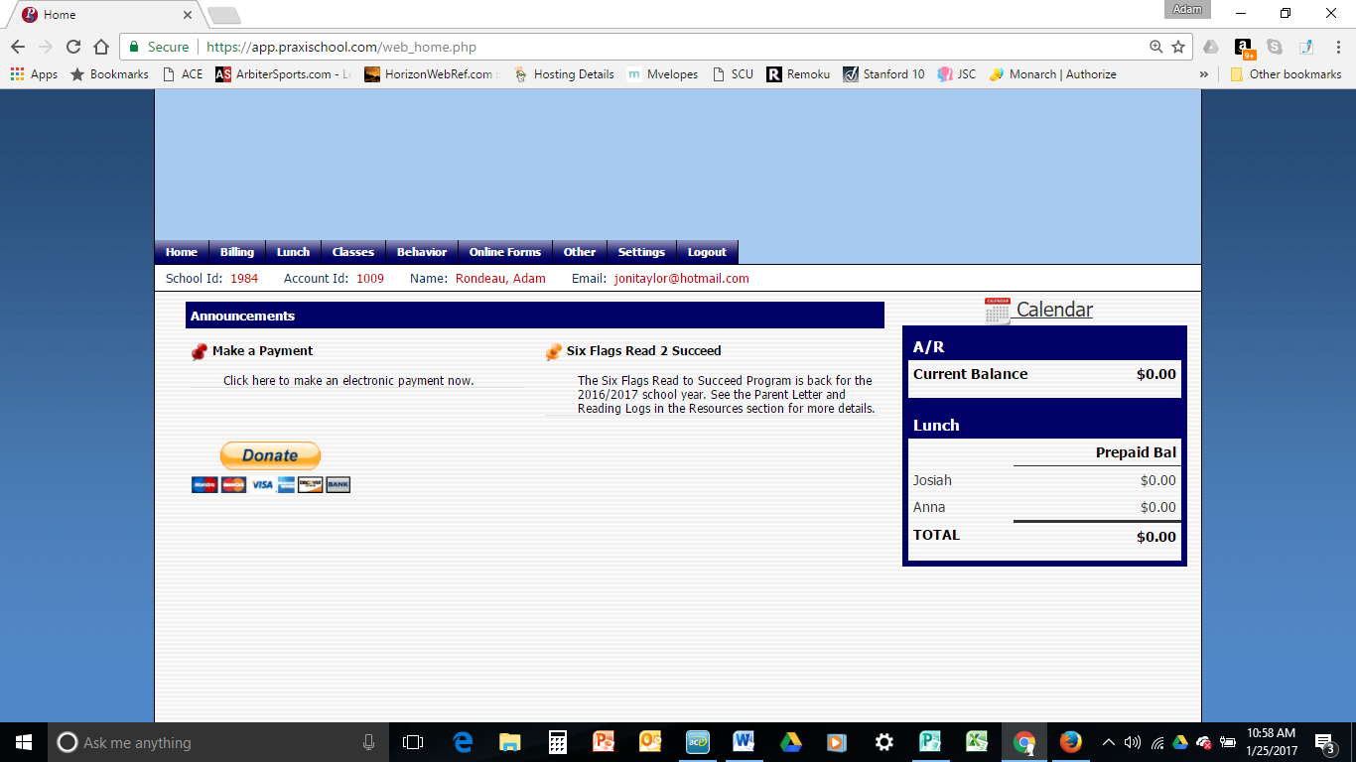

Just Added. Link for electronic payments available on parent portal homepage

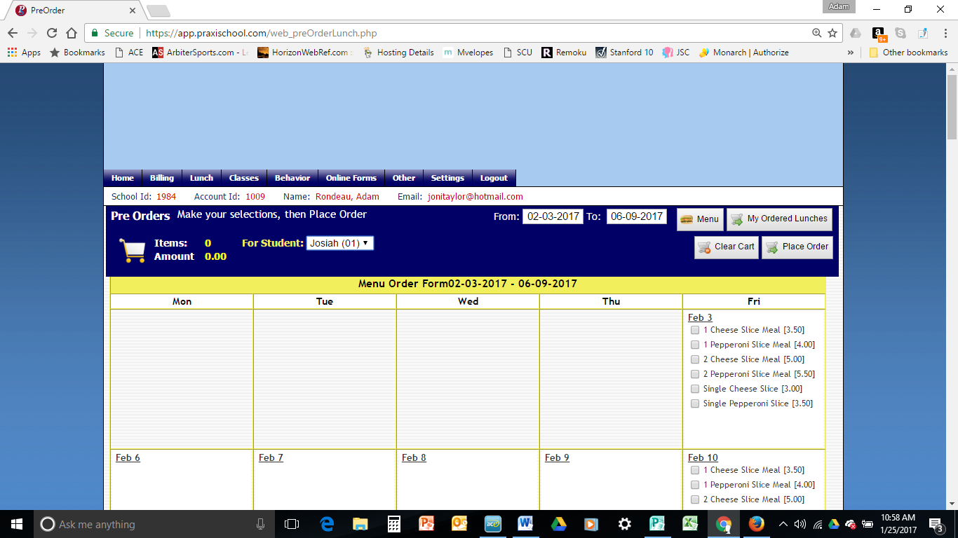

Toggle between students in same family.

Just click what you would like to order.

Will make menu available to place orders.